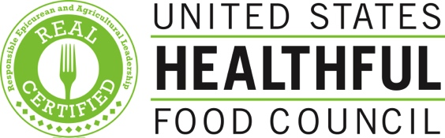

FOR IMMEDIATE RELEASE
Media contact: Elizabeth Bennett
561-789-0571, elizabeth@ushfc.org

First California Restaurants Earn REAL Certification

San Francisco, CA (June 17, 2014) – This morning at the former Archbishop’s Mansion, the United States Healthful Food Council (USHFC) announced California’s first restaurants to achieve REAL Certification. Responsible Epicurean and Agricultural Leadership (REAL) Certification is a growing national program that helps combat diet-related disease by recognizing restaurants and foodservice operators committed to holistic nutrition and environmental stewardship.

“Americans are consuming an increasing percentage of food prepared by others, with little to no transparency,” said Lawrence Williams, CEO of the USHFC. “REAL Certification gives consumers confidence that they are eating at establishments that understand the link between their menu offerings and their consumers’ long-term health.”

The first California REAL Certified restaurants are: Nopa, The Plant Café Organic, Epic Roasthouse, Waterbar, Radius, Tambo, ‘wichcraft, Cool Beans, Hot Italian, and Mixt Greens. Rebecca Jean Catering and the prepared food section at Real Food Company have also achieved REAL Certification. Numerous top chefs, restaurateurs, food reviewers, and other thought leaders in culinary nutrition participated in the launch event, which included a menu designed by Chef Dave Smith and the event sponsor, the California Walnut Board and Commission.

“We’re committed to serving healthful, local, and sustainable food,” said Laurence Jossel, chef and co-owner of Nopa. “We believe our mission is aligned with that of the USHFC and we are proud to promote Eat REAL California.”

Utilizing the points-based REAL Index, independent registered dietitians conduct an assessment of menu offerings and overall nutrition and sustainability practices. Establishments are credited with points across a range of criteria such as the use of vegetables, fruits, whole grains, healthy preparation methods, moderate portion sizes, unsweetened beverages, healthy children’s options and sustainable sourcing practices. Those that satisfy the necessary requirements are awarded REAL Certification.

“Programs like Eat REAL have the potential to encourage restaurants and foodservice companies to respond to the increasing consumer demand for more healthful and ethical eating options,” said Michele Simon, author and president of Eat Drink Politics. “And California, mecca of the good food movement, is an ideal place for this promising project to expand its reach.”

The newly certified California establishments mark a milestone in the growth of REAL Certification, which launched with a restaurant campaign in Washington, DC, last year and has since expanded nationally to over 100 locations that include restaurants and public venues. Through a partnership with the national foodservice management company Guckenheimer, the USHFC is also certifying dining facilities at dozens of corporate sites across the country.

ABOUT THE UNITED STATES HEALTHFUL FOOD COUNCIL (USHFC)
Established in 2011, the USHFC is a nonprofit, nongovernmental organization dedicated to fighting diet-related disease by realigning the food industry’s incentives with consumers’ health interests. The USHFC works towards its mission through the Responsible Epicurean and Agricultural Leadership (REAL) Certification, which assesses and certifies food and foodservice establishments based on nutrition and sustainability best practices. The organization receives financial support through grants from the Tennessee Department of Health, the Park Foundation and the Robert Wood Johnson Foundation President’s Grant Fund of the Princeton Area Community Foundation. More information can be found at ushfc.org and eatREAL.org.

###

